Similar to vfaq's tutorial I will show you how to create a rear o2 bypass/simulator using parts available from your local radio shack.
Parts needed:
1 - Mohm resistor
3 - 50ohm/10watt resistors
1 - 1µF capacitor
(It is possible to use other variations than the 50ohm/10watt resistors I have chosen, like I said this is what was available. Myself and others have proven that they work perfectly fine)
I began by gathering all the parts required and I personally purchased a cheap aluminum box to contain everything once finished. To establish the best connection I would highly recommend soldering each connection. (also available at radio shack)
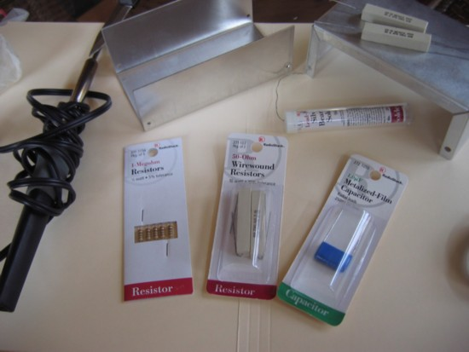
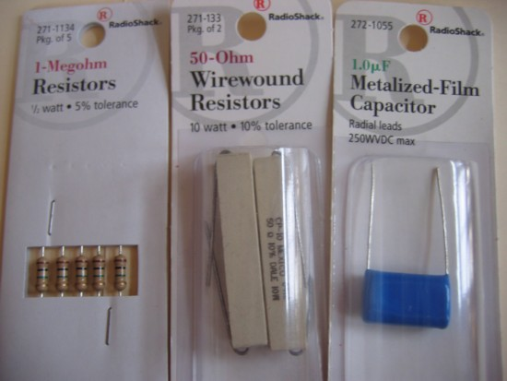
One option would be to remove the entire sensor and line from the vehicle and attach it to the existing wires. I decided I was going to just splice it underneath the vehicle. I didnt have much wire to choose from at home so I simply used some thick stranded wire I found and cut out points on it as shown below.
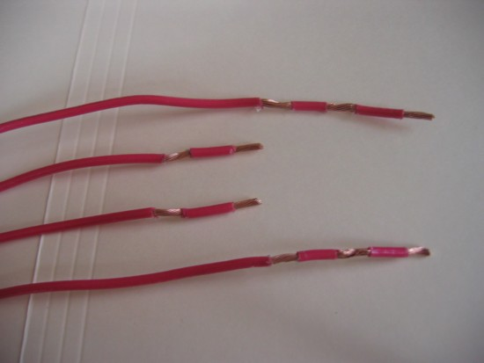
The layout, (the colors are accurate/same wire colors on the sensor)
View attachment o2 sim layout.bmp
I set all the parts in order for them to be soldered to the wiring.
Edit: I was notified that I had switched the resistor and capacitor around from my diagram. I didn't even realize that. Not a problem though, they are in parallel so either way works.
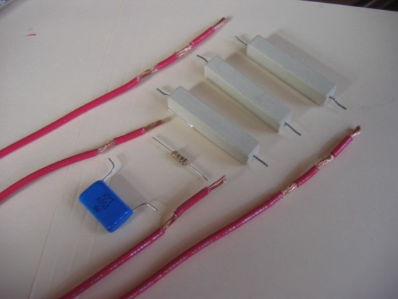
Then soldered everything together
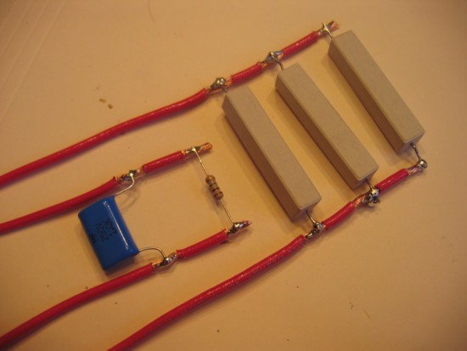
Next I taped everything up and played with the aluminum box in my vise and created a smaller mountable enclosure.
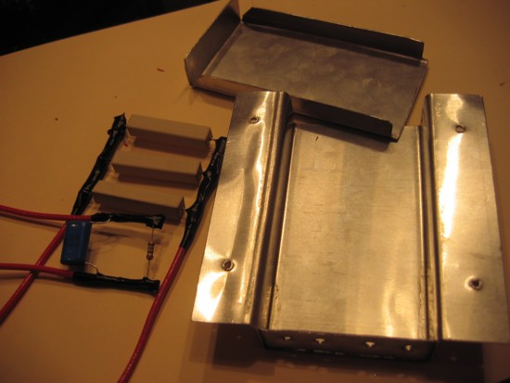
Placed everything inside
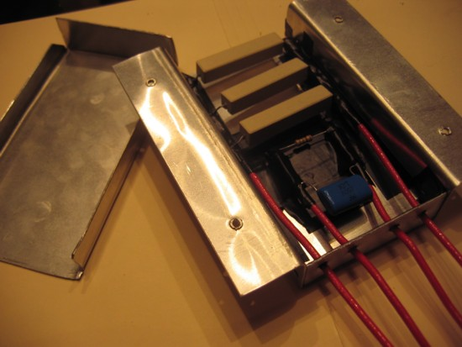
And that's it! Just splice the corresponding wires to the o2 wires. Obviously I did a little extra than necessary and took some different steps but those are the basics
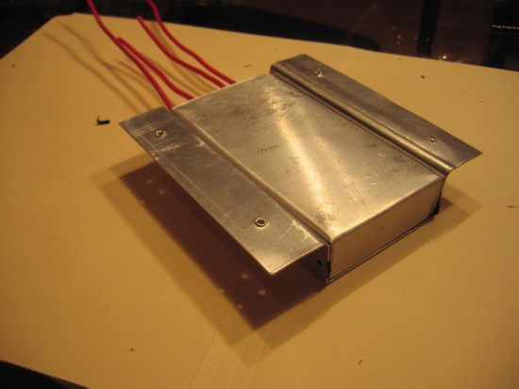
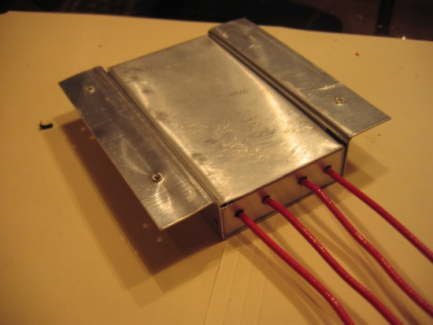
*It has been brought to my attention that some have said that the 3 50ohm resistors are not enough, I personally have never had a problem but being the case there is no harm in adding a 4th resistor.

