GM Alternator Swap

First off I'd like to credit a local to me, David Landry, for the idea and tips on getting this done.
This is a relatively cheap and easy way to solve DSM alternator woes...Here is the process to swap a GM (93-99 Saturn 1.9L DOHC) Alternator into a 1G DSM. The same process can be followed for a 2g(except wiring).
I have a total cost of $26.17 in this swap, thanks to Pull-a-Part.
1) Make/Model/Year these alternators are found on.
These alternators are found on any Saturn from 91 to 97 with 1.9L (I think they all have 1.9L, and 98 and 99 years may work also)
2) 1g/2g wiring for the alternator
(1G)The 1G connector is a 2 wire just like the Saturn alternator. The large yellow wire goes to the F terminal (black wire on the Saturn connector).
The small black wire goes to the L terminal (black with white stripe wire on Saturn connector).
(2G) The 2g connector has 4 wires, but you will only use the 2 middle wires! The Red wire (Field Wire) goes to the F terminal (Black wire on the Saturn connector).
The black with yellow stripe wire (light wire) goes to the L terminal (Black with white stripe wire on the Saturn connector)
NOTE: The Red wire on the 2g connector has 12 volts even with the key off. Unhook your battery before doing this!
Also, the Saturn plug sometimes has Brown wires and not black, but the terminals are marked on the plug, and the alternator case. You will be using the 2 middle terminals only. L(light) and F(field)
3) Recommended gauge charge wire and fuse to use when using these alternators
If you use the stock Saturn (96) amp, then you can use your stock power wire.
STOCK (96 AMP) - use 10 gauge (stock) charge wire.
HIGH AMP (160 AMP) Manufacturer recommends 4 gauge charge wire.
HIGH AMP (200 AMP) Manufacturer recommends 4-2 gauge charge wire.
(If you buy a high amp alternator, they will let you know The proper alternator fuse for your application)
Ebay:
Stock (96 amp) reman for 67 shipped
200 amp Saturn alternator for 178 shipped
or a 160 amp Saturn alternator, for 148 shipped
4) Jay racing has now made Their alternator relocate kit to work with the Saturn alternators. You will have to tell them you are using a Saturn alternator!
http://www.jayracing.com/index.php?m...dex&cPath=8_10
Main Phone: 937.248.7846
Service Shop Phone: 937.248.9720
On to the fun...
Saturn, meet Mitsubishi:
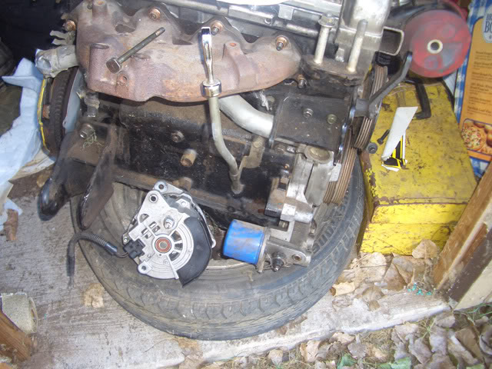
There is material that has to be ground down on the alternator case.
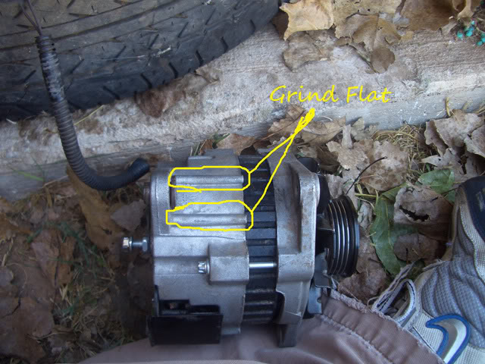
The mount on the motor needs to be ground on to allow the Saturn alternator to rotate.
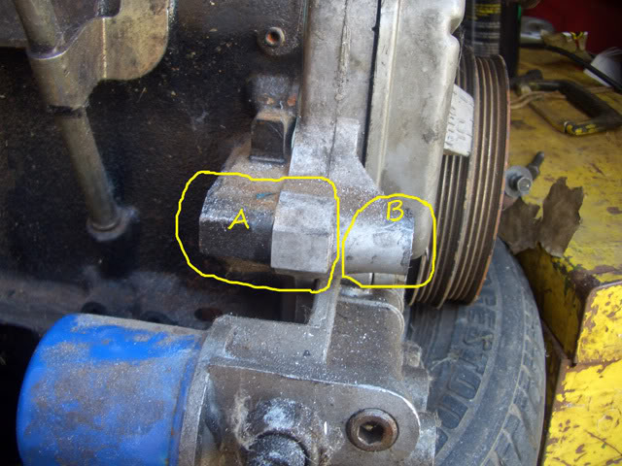
Grind "A" to match the shape of "B"
That's it, you still use the stock upper bracket and tensioner, you flip the tensioner so it will clear the fan on the Saturn alternator.
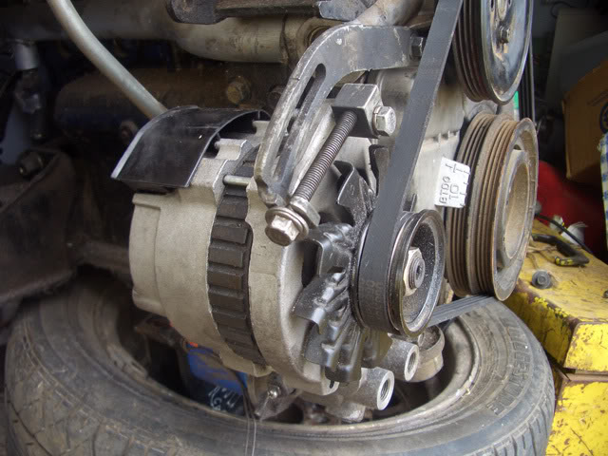
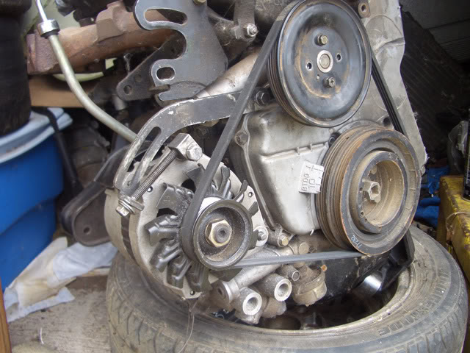
I used a Dremel to do this on both my spare motor and in the car, it took maybe 30 minutes of grinding, which could have been done in 5-10 with a real grinder.
The 1G connector is a 2 wire just like the Saturn alternator.
The large yellow wire goes to the F(black) wire on the Saturn alternator. The small black wire goes to the L (black with white stripe).
2G Owners: the large yellow wire goes to the F(black) wire on the Saturn connector and the small black wire goes to the L(black w/ white stripe) on the Saturn connector.
One thing that i don't like is that the Saturn alternator pulley has one too many groves, but that hasn't affected anything so far and it has seen 9000 rpms.

Another post. No Pictures. 2G Specific.
Unfortunately, they are 2g specific, but the 1g specifics are fairly well taken care of in other threads. It is the 2g that seems to be a bit in the dark.
The car is a 99 dsm with stock manifold and o2 housing, stock block (7bolt). The alternator I bought was a rewound 160A CS130D.
1) There are two types of "CS2" alts out there, CS130 and CS130D. CS130D is the newer style. The biggest difference is the 'D' version has an internal fan. There are other minor differences that I can't recall at this time. Generally, the CS130D is considered the better alternator.
2) I did NO grinding on the alternator. I did a little grinding on the block, shaved the upper face and the side a touch (the mounting block for the alt).
3) I snipped the twin 8ga on both ends, ran a 4ga from the alt under the radiator to the fuse box. I ran a 4ga from the fuse box to the battery, removed the twin 8ga that ran between the fuse box and battery.
4) I added a 4ga wire to the bottom mounting bolt of the alternator right under the oil pan to the center brace, down the center brace and straight up under the battery pan to the negative battery terminal.
5) The 99s do not have a generator relay, so there is no black/yellow wire on the stock alt harness. The wire you are interested in is the blue wire. I couldn't get a straight answer on the resistance of the path, so I wired in a 50 Ohm resistor in series with the blue wire. This wire is hooked to 'L' on the CS130D.
6) I ran a 14ga wire from 'S' on the CS130D to the fuse box. Currently it is sitting on the bolt of the 60A alt choke fusible link (the 4ga from the alt is on the 100A alt choke...electrically, they are the same point). This isn't quite ideal as it is most likely not the point of lowest voltage drop in the car. The whole point of 'S' is to give feedback to the alt on how it is doing...if it needs to output more, or to tone it down a bit.
7) The tensioner was flipped still (no fan to worry about on the CS130D) to provide a better angle for the tension bolt, it does not sit flush and I cowboyed it with some wire in an attempt to keep the bolt from 'jumping' loose of the bracket. This is temporary until I get around to getting a wedge shaped piece in there.
8) Needed a new bolt for the tensioner. 8M with a lock nut is perfect.
9) The alt shop gave me the 2" pulley with 5ribs. It seems to line up the best with the belt on the ribs closest to the alt ( two ribs uncovered towards the driver's side).
10) There was no clearance issue with tightening the alt belt because of the stock oil cooler.
11) To get the alt out, I just had to pull the driver's fan and o2 sensor. I left the power steering pump intact.
12) I had to bend the coolant pipe towards the block and towards the dipstick to make room for the CS130 alt. Draining from the lower rad hose did NOT drain from the block so when you remove the rubber hose, have a quick finger, funnel, and jug ready to get the antifreeze. Slide over a length of pipe and carefully push it towards the passenger's rear wheel.
13) The 4ga wires going in and out of the fuse box do not fit nicely. I will have to go in and snip away at some of the plastic to get the original harness to sit right.
14) I did NOT use the 'F' terminal on the alternator. Just 'S' and 'L'.
15) Right now, I'm getting P1500 CEL, which is 'Generator FR Terminal Error' Basically, the ECU on the 2gs have control over the alt via two wires. Generator G and Generator FR. The ECU can control 'G' based on what 'FR' is doing. (G is an OP and FR is an IP) Since we no longer rely on the ECU to control the alt's output, we can safely ignore P1500 CEL. However, it's annoying having that light. So, I think the solution to this is to ground Generator FR in the stock harness. (I don't have the wiring diagram in front of me to confirm the colour/pin on the harness) I have not tested this yet, nor do I know enough to tell people to do this. I will ground FR when I get the chance to do a proper job of it and see how it goes.
Materials:
1) 22' of 4ga wire (extra is included, I used about 10' for the positive lines, 8' for the new ground)
2) 6 4ga ring terminals. (4 red, 2black)
3) 12' of 14ga wire (extra is included, ~8' to get to the fuse box)
4) 1 14ga ring terminal
5) 1 50 Ohm resistor (any resistor between 35-100 Ohm should be good...this is only needed for a 99)
So far results are promising. 14.7 at idle with all stock accessories rocking...HVAC, brights, 1 fan, brake lights, etc... this it ~875rpm idle. My amp was 'temporary' out of service, so didn't have a chance to really stress the idle voltage too much. Another great plus is no grinding was needed on the alt itself to make it fit, which means I can buy a CS130D off the shelf and just drop it in now if I ever need to replace.
If I seemed to have left anything out, just ask and I'll get back to ya.

This is a simple bracket that will retain the function and location of the OEM tensioner and still work perfect with your Saturn alternator.
I've seen various bracket ideas but this one combines ideas I've seen from two DSMTuners members, H@xtGSX and I'm sorry but I can't remember the other member but his idea uses a straight piece instead. I'll update the How-To if it comes to me later. Anyway, this bracket method keeps the alignment of the OEM tensioner screw at the correct angle and allows you to lock-down your setting in the bracket slot just as you would with the stock alternator.
Materials:
- (2x) bolts, nuts, lock washers (I'll update with sizes)
- (1x) 6" x 1/8" x 1" flat steel
Tools
- Drill
- Wrenches
- Vise
I don't think there needs to be too much explanation as to how this works.
You can look at the picture and see that it is simply 2 - 45* bends and two holes drilled on either end to join the alternator to the stock adjuster.
Note: You may notice that you can go with a straight piece here without the 45's but then I found it throws off the angle of the adjustment screw when you put it under the triangle block thingy. Also, it's not exactly a straight line from the alternator to the bracket so it's in in there a bit cocked. Locating the flat steel to the outside of the triangle block eliminates all of that.
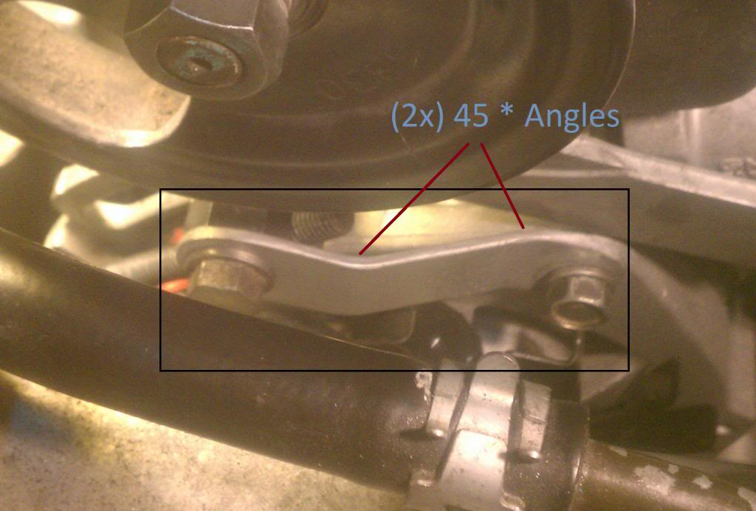
How it's done
- First, if you haven't already done so get your block, and alternator grinding done until you have an acceptable range of movement.
- Now with the bottom pivot bolt holding the alternator on, place something (I used a screwdriver handle) under your alternator to hold it all the way up at the maximum position.
- Unscrew the OEM adjustment screw from the triangle block until only one or two threads are showing from the end.
- Place your OEM adjustment screw in its notch and use a bolt, lock washer, and nut to hold the triangle block in the long slot in the bracket.
- You should now have the OEM adjuster mounted with the adjuster fully extended and the alternator mounted being held at full height
Making the Bracket
- Next, make your two 45* bends on your piece of flat steel
- Lay the piece in place where it will sit and then mark the location of the holes
- Drill your holes and trim any excess material from the ends Note: Drill your holes so they are a tight fit to your bolts. I did mine a bit bigger and had more play than I would like.
- Paint it and mount it up.. You definitely want to use lock washers here.
You're done
Now just tension your belt like you normally would have with your OEM alternator.
